CLASS 12TH UNIT 2: Data Science Methodology: An Analytic Approach to Capstone Project
A. Objective Type Questions
Que. 1) Which is the hardest stage in the foundational methodology of Data Science?
Ans:- c. Modelling
Que. 2) Business Sponsors defines the problem and project objectives from a ________ perspective.
Ans:- c. Business
Que. 3) Match the following and choose the correct option.
Ans:- d. (i)–A, (ii)–C, (iii)–B, (iv)–D
Que. 4) Arrange the following statements in order.
Ans:- b. iv, ii, iii, i
Que. 5) Data Modelling focuses on developing models that are either ___________ or ____________.
Ans:- b. Predictive, Descriptive
Que. 6) Statement 1: There is no optimal split percentage. Statement 2: The most common split percentage between training and testing data is 20%-80%.
Ans:- a. Statement 1 is true and Statement 2 is false.
Que. 7) Train-test split function is imported from which Python module?
Ans:- a. sklearn.model_selection
Que. 8) Identify the incorrect statement.
Ans:- c. ii only
Que. 9) Identifying the necessary data content, formats and sources for initial data collection is done in which step of Data Science methodology?
Ans:- a. Data requirements
Que. 10) Data sets are available online. From the given options, which one does not provide online data?
Ans:- d. Edge
Que. 11) A ____________ set is a set of historical data in which outcomes are already known.
Ans:- a. Training set
Que. 12) _____________ data set is used to evaluate the fit machine learning model.
Ans:- b. Test set
Que. 13) x_train,x_test,y_train,y_test = train_test_split(x, y, test_size=0.2) From the above line of code, identify the training data set size.
Ans:- b. 0.8
Que. 14) In k-fold cross validation, what does k represent?
Ans:- d. all of the above
Que. 15) Identify the correct points regarding MSE.
Ans:- c. iii and iv

B. Short Answer Questions
Que. 1) How many steps are there in Data Science Methodology? Name them in order.
Ans:- There are 10 steps in the Data Science Methodology proposed by John Rollins. They are organised into five modules: From Problem to Approach, From Requirements to Collection, From Understanding to Preparation, From Modelling to Evaluation, and From Deployment to Feedback. The ten stages are Business Understanding, Analytic Approach, Data Requirements, Data Collection, Data Understanding, Data Preparation, AI Modelling, Evaluation, Deployment and Feedback.
Que. 2) What do you mean by Feature Engineering?
Ans:- Feature Engineering is the process of selecting, modifying or creating new features (variables) from raw data to improve the performance of machine learning models. For example, from house area and year of construction, features such as age of the house and price per square foot can be created.
Que. 3) Data is collected from different sources. Explain the different types of sources with example.
Ans:- Data is mainly collected from primary and secondary sources. A primary data source provides original data collected firsthand through methods such as observation, experiments, surveys, interviews and IoT sensors. A secondary data source provides data that is already stored and available for use, such as data from books, journals, websites and internal databases. Examples of online secondary data sources include UNICEF, World Health Organization, Google, Kaggle and World Bank Open Data.
Que. 4) Which step of Data Science Methodology is related to constructing the data set? Explain.
Ans:- The Data Understanding step is related to constructing the dataset. In this stage, the collected data is checked to determine whether it is representative of the problem. Its relevance, completeness and suitability are examined using techniques such as descriptive statistics and visualisation.
Que. 5) Write a short note on the steps done during Data Preparation.
Ans:- Data Preparation is the stage in which data is converted into a suitable form for modelling. It includes cleaning the data, dealing with missing or invalid values, removing duplicate values, assigning suitable formats, combining data from multiple sources and transforming data into meaningful input variables. Feature Engineering is also a part of Data Preparation.
Que. 6) Differentiate between descriptive modelling and predictive modelling.
Ans:- Descriptive modelling focuses on summarising and understanding the characteristics, patterns and trends present in a dataset without making predictions. It uses techniques such as summary statistics and visualisations. Predictive modelling, on the other hand, uses historical data, statistical algorithms and techniques such as regression, classification and time-series forecasting to predict future outcomes or values.
Que. 7) Explain the different metrics used for evaluating Classification models.
Ans:- The main metrics used for evaluating classification models are Precision, Recall, F1-score and Accuracy. Precision measures the proportion of predicted positive cases that are actually positive. Recall measures the proportion of actual positive cases that are correctly classified. F1-score combines Precision and Recall and is useful when both false positives and false negatives are important. Accuracy represents the proportion of correct predictions out of the total predictions.
Que. 8) Is Feedback a necessary step in Data Science Methodology? Justify your answer.
Ans:- Feedback is a necessary step in Data Science Methodology because it helps determine whether the problem has been solved satisfactorily. Feedback is collected from users and clients after deployment and is used to improve the model's performance and impact. The process continues until the model provides satisfactory and acceptable results.
Que. 9) Write a comparative study on train-test split and cross validation.
Ans:- Train-test split divides a dataset into a training dataset and a test dataset, where the training data is used to fit the model and the test data is used to evaluate it. It is normally suitable for large datasets. Cross validation divides the dataset into multiple folds, trains the model on some folds and tests it on the remaining fold, repeating the process for all folds. It is normally preferred with small datasets because it provides multiple measures of model quality, although it takes more time to run.
Que. 10) Why is model validation important?
Ans:- Model validation is important because it helps measure the accuracy and reliability of a trained machine learning model on new and unseen data. It improves model quality, reduces the risk of errors and helps prevent overfitting and underfitting.
Que. 1) Explain the procedure of k-fold cross validation with suitable diagram.
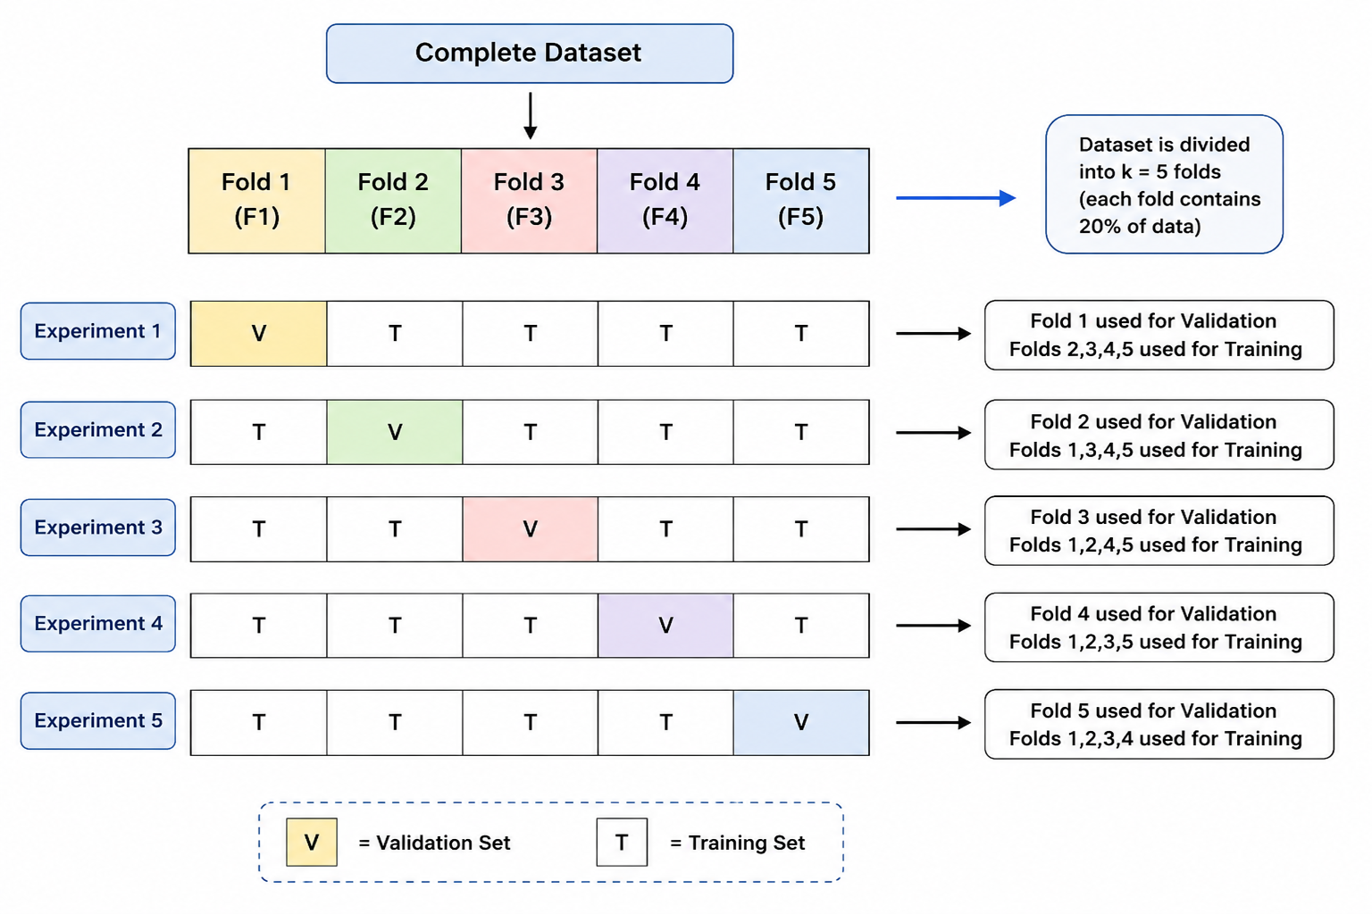
Introduction:
K-fold cross validation is a model validation technique used to evaluate the performance of a model. It divides the dataset into multiple parts called folds. The model is trained on some folds and tested on the remaining fold, and this process is repeated for a fixed number of the dataset.
1. The complete dataset is divided into k folds. For example, when k = 5, the dataset is divided into five folds, with each fold containing about 20% of the data.
2. In the first experiment, the first fold is used for validation, while the remaining four folds are used for training.
3. In the second experiment, the second fold is used for validation, while the remaining folds are used for training.
4. This process is repeated until each fold has been used once as the validation set.
5. The results obtained from all the experiments provide multiple measures of model quality, making the evaluation more reliable.
Conclusion:- Thus, k-fold cross validation provides a more accurate measure of model quality because the model is evaluated using different subsets of the data. However, it takes more time because the model is estimated once for each fold.

Que. 2) Data is the main part of any project. How will you find the requirements of data, collect it, understand the data and prepare it for modelling?
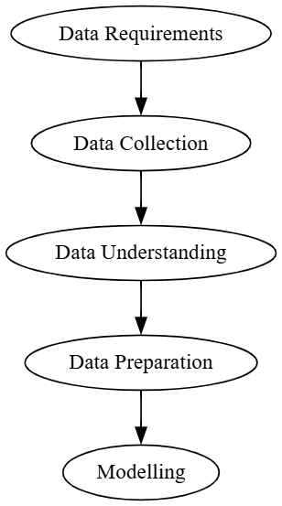
Introduction:- Data is the foundation of any AI/ML project. Before building a model, it is important to identify what data is required, collect it from suitable sources, understand its characteristics and prepare it properly for modelling.
1. Determine what type of data is needed, how much data is required and which features/attributes are important for solving the problem.
2. Collect relevant data from reliable sources such as surveys, databases, sensors, websites, APIs, forms or existing datasets.
3. Examine the collected data to understand its size, structure, features, data types and patterns. Identify missing values, duplicate records and unusual values.
4. Remove or correct errors, duplicate records and irrelevant data. Handle missing values and convert data into a suitable format for analysis.
5. Perform necessary data transformation and preprocessing, such as encoding categorical data, scaling numerical values and selecting relevant features. Finally, divide the data into training and testing sets.
Conclusion:- Thus, identifying the correct data requirements, collecting suitable data, understanding its quality and preparing it properly helps in creating a usable and accurate dataset for modelling.

